- Program ID : VA001MA1

- Display Layout
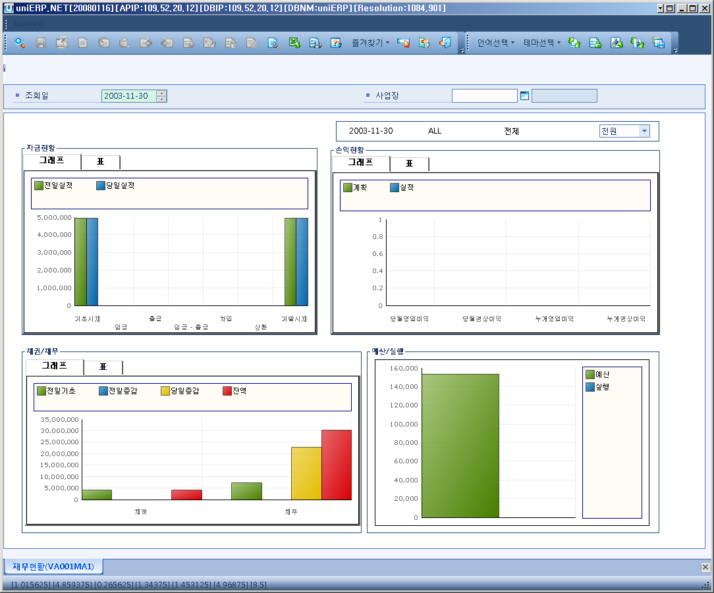

- Event flow
- Click Query button
- OnFncQuery -> DbQuery -> DataChange
- Display Unit combo change
- uniCombo1_ValueChanged -> DataChange

- SQL Statements
- Basis amount, receipts, payment, receipts - payment, amount at term end, loan, refund
SELECT SUM(VA002AT.BAS_AMT), SUM(VA002AT.RECEIPT_AMT), SUM(VA002AT.ISSUE_AMT), SUM(VA002AT.DIFF_AMT),
SUM(VA002AT.LOAN_AMT), SUM(VA002AT.REFUND_AMT), SUM(VA002AT.INV_AMT)
FROM VA002AT
WHERE VA002AT.SP_ID = @strSpid
AND VA002AT.YYYYMMDD = DATEADD(DD, -1, @strDate)

- Money status – the day’s result
SELECT SUM(VA002AT.BAS_AMT), SUM(VA002AT.RECEIPT_AMT), SUM(VA002AT.ISSUE_AMT), SUM(VA002AT.DIFF_AMT),
SUM(VA002AT.LOAN_AMT), SUM(VA002AT.REFUND_AMT), SUM(VA002AT.INV_AMT)
FROM VA002AT
WHERE VA002AT.SP_ID = @strSpid
AND VA002AT.YYYYMMDD = @strDate

- Operating profit – monthly plan
SELECT SUM(VB000AT.PLAN_AMT)
FROM VB000AT
WHERE VB000AT.YYYYMM = LEFT(@strDate, 6)
AND VB000AT.BS_PL_FLAG = 'M'

- Operating profit – monthly result
SELECT SUM(VB000BT.BS_PL_AMT)
FROM VB000BT
WHERE VB000BT.YYYYMM = LEFT(@strDate, 6)
AND VB000BT.BS_PL_FLAG = 'M'

- Ordinary income – monthly plan
SELECT SUM(VB000AT.PLAN_AMT)
FROM VB000AT
WHERE VB000AT.YYYYMM = LEFT(@strDate, 6)
AND VB000AT.BS_PL_FLAG = 'P'

- Ordinary income – monthly result
SELECT SUM(VB000BT.BS_PL_AMT)
FROM VB000BT
WHERE VB000BT.YYYYMM = LEFT(@strDate, 6)
AND VB000BT.BS_PL_FLAG = 'P'
- Operating profit – total sum of plan
SELECT SUM(VB000AT.PLAN_AMT)
FROM VB000AT
WHERE VB000AT.YYYYMM BETWEEN LEFT(@strFiscDate, 6)
AND LEFT(@strDate, 6)
AND VB000AT.BS_PL_FLAG = 'M'

- Operating profit – total sum of result
SELECT SUM(VB000BT.BS_PL_AMT)
FROM VB000BT
WHERE VB000BT.YYYYMM BETWEEN LEFT(@strFiscDate, 6)
AND LEFT(@strDate, 6)
AND VB000BT.BS_PL_FLAG = 'M'

- Ordinary income – total sum of plan
SELECT SUM(VB000AT.PLAN_AMT)
FROM VB000AT
WHERE VB000AT.YYYYMM BETWEEN LEFT(@strFiscDate, 6)
AND LEFT(@strDate, 6)
AND VB000AT.BS_PL_FLAG = 'P'

- Ordinary income – total sum of result
SELECT SUM(VB000BT.BS_PL_AMT)
FROM VB000BT
WHERE VB000BT.YYYYMM BETWEEN LEFT(@strFiscDate, 6)
AND LEFT(@strDate, 6)
AND VB000BT.BS_PL_FLAG = 'P'

- AR - AP
SELECT v1.AR_AP_FLAG,
v1.BAS_INC_AMT - v1.BAS_DEC_AMT,
v1.LAST_INC_AMT - v1.LAST_DEC_AMT,
v1.INC_AMT - v1.DEC_AMT,
(v1.BAS_INC_AMT - v1.BAS_DEC_AMT) + (v1.LAST_INC_AMT - v1.LAST_DEC_AMT) + (v1.INC_AMT - v1.DEC_AMT)
FROM (SELECT ISNULL(SUM(CASE WHEN V.QDATE BETWEEN CONVERT(CHAR(6), DATEADD(DD, -2, @strDate), 112) + '00' AND CONVERT(CHAR(8), DATEADD(DD, -2, @strDate), 112) THEN V.INC_AMT END), 0) BAS_INC_AMT,
ISNULL(SUM(CASE WHEN V.QDATE BETWEEN CONVERT(CHAR(6), DATEADD(DD, -2, @strDate), 112) + '00' AND CONVERT(CHAR(8), DATEADD(DD, -2, @strDate), 112) THEN V.DEC_AMT END), 0) BAS_DEC_AMT,
ISNULL(SUM(CASE V.QDATE WHEN CONVERT(CHAR(8), DATEADD(DD, -1, @strDate), 112) THEN V.INC_AMT END), 0) LAST_INC_AMT,
ISNULL(SUM(CASE V.QDATE WHEN CONVERT(CHAR(8), DATEADD(DD, -1, @strDate), 112) THEN V.DEC_AMT END), 0) LAST_DEC_AMT,
ISNULL(SUM(CASE V.QDATE WHEN @strDate THEN V.INC_AMT END), 0) INC_AMT,
ISNULL(SUM(CASE V.QDATE WHEN @strDate THEN V.DEC_AMT END), 0) DEC_AMT, AR_AP_FLAG
FROM ( SELECT A.FISC_YR + A.FISC_MNTH + A.FISC_DT 'QDATE',
CASE WHEN B.ACCT_TYPE IN ('I0','I1') THEN 'AR'
WHEN B.ACCT_TYPE IN ('JA','JD') THEN 'AP' END 'AR_AP_FLAG',
SUM(CASE WHEN B.ACCT_TYPE IN ('I0','I1') THEN A.DR_LOC_AMT
WHEN B.ACCT_TYPE IN ('JA','JD') THEN A.CR_LOC_AMT END) 'INC_AMT',
SUM(CASE WHEN B.ACCT_TYPE IN ('I0','I1') THEN A.CR_LOC_AMT
WHEN B.ACCT_TYPE IN ('JA','JD') THEN A.DR_LOC_AMT END) 'DEC_AMT'
FROM A_GL_SUM A(NOLOCK), A_ACCT B(NOLOCK)
WHERE A.ACCT_CD = B.ACCT_CD
AND B.ACCT_TYPE IN ('I0','I1','JA','JD') -- 외상매출금(국내), 외상매출금(외화), 외상매입금(국외), 외상매입금(국내)
AND A.FISC_YR + A.FISC_MNTH + A.FISC_DT BETWEEN CONVERT(CHAR(6), DATEADD(DD, -2, @strDate), 112) + '00' AND @strDate
AND A.BIZ_AREA_CD LIKE @strBizAreaCd + '%'
GROUP BY A.FISC_YR + A.FISC_MNTH + A.FISC_DT ,
CASE WHEN B.ACCT_TYPE IN ('I0','I1') THEN 'AR'
WHEN B.ACCT_TYPE IN ('JA','JD') THEN 'AP' END) V
GROUP BY AR_AP_FLAG) v1
ORDER BY v1.AR_AP_FLAG DESC

- Budget and Execution
SELECT SUM(F_BDG.BDG_AMT), SUM(F_BDG.BDG_GL_AMT)
FROM F_BDG
WHERE F_BDG.BDG_YYYYMM = LEFT(@strDate, 6)
AND F_BDG.BIZ_AREA_CD LIKE @strBizAreaCd + '%'

